East High School 2015-16
Drawing and Painting 2
“The arts teach students the importance of using imagination, multiple perspectives, and personal interpretation. Instead of conformity, the arts enable students to think and exercise creativity.” –Mara Krechevsky

Mrs. Justine Sawyer Email: justine_sawyer@dpsk12.org Classroom: 125
Course Website: www.justinesawyerartteacher.weebly.com
Please contact me anytime to schedule an appointment with inquiries, concerns or compliments!

Course Description:
Drawing and Painting 2 is a year-long course for students who have successfully completed Drawing and Painting 1 and want to further improve their artistic skills. Based on the Visual Art Standards, students will be expected to produce a higher quality body of work with more emphasis on craftsmanship, aesthetic value and personal expression. The goal of this course is for students to create a quality body of work, explore their artistic skills using a variety of media for painting and drawing as the vehicle of expression and communication, reflect verbally and in writing about their outcomes, and create an online portfolio of personal works. Entering work into art competitions and exhibitions is encouraged.

Materials Fee and Sketchbook:
*Students are expected to pay $40.00 for the year for this course. This fee helps provide students with many diverse marking materials needed for success in this course. Please see the treasurer outside the main office to pay your fee. If the fee is a financial hardship, students may apply for financial aid from the East High School Angel Foundation in Room 130. Students must demonstrate the financial burden in order to receive financial assistance.

*Sketchbook – If you lose yours, you can buy one from me for $8.00 or you can get one from Michael’s, Hobby Lobby, Target, Meininger’s, Guiry’s, etc. for a variety of styles and prices

Upon completion of the course, the student should be able to: (Essential Learning Goals)
- Explore design elements, technical quality, and conceptual concerns at a more advanced level.
- Develop students into critical thinkers that can analyze and interpret their artwork and the artwork of others.
- Investigate works of art by artists and the visual problems they address.
- Create artwork that shows evolving thought and growth towards mastery of the medium.
- Use decision-making skills to plan artwork, choose appropriate media, and apply the correct techniques to create the work.
- Deepen development of a style or voice that is unique to the individual student.
- Express ideas about art using visual, verbal, and written forms of communication.
- Demonstrate behaviors that reflect the habits of professional artists.

Colorado Standards for Visual Art
1. Observe and Learn to Comprehend | 1. | Visual art has inherent characteristics and expressive features
 | 2. | Historical and cultural context are found in visual art
 | 3. | Art and design have purpose and function
2. Envision and Critique to Reflect | 1. | Reflective strategies are used to understand the creative process
 | 2. | A personal philosophy of art is accomplished through use of sophisticated language and studio art processes
 | 3. | Interpretation is a means for understanding and evaluating works of art
3. Invent and Discover to Create | 1. | Demonstrate competency in traditional and new art media, and apply appropriate and available technology for the expression of ideas
 | 2. | Assess and produce art with various materials and methods
 | 3. | Make judgments from visual messages
4. Relate and Connect to Transfer | 1. | The work of art scholars impacts how art is viewed today
 | 2. | Communication through advanced visual methods is a necessary skill in everyday life
 | 3. | Art is a lifelong endeavor
Studio Habits of the Mind
Develop Craft | Learning to use and care for tools (e.g., viewfinders, brushes), materials (e.g., charcoal, paint). Learning artistic conventions (e.g., perspective, color mixing).
Engage & Persist | Learning to embrace problems of relevance within the art world and/or of personal importance, to develop focus and other mental states conducive to working and persevering at art tasks.
Envision | Learning to picture mentally what cannot be directly observed and imagine possible next steps in making a piece.
Express | Learning to create works that convey an idea, a feeling, or a personal meaning.
Observe | Learning to attend to visual contexts more closely than ordinary "looking" requires, and thereby to see things that otherwise might not be seen.
Reflect | Question & Explain: Learning to think and talk with others about an aspect of one’s work or working process.  Evaluate: Learning to judge one’s own work and working process and the work of others in relation to standards of the field.
Stretch & Explore | Learning to reach beyond one's capacities, to explore playfully without a preconceived plan, and to embrace the opportunity to learn from mistakes and accidents.
Understand Art World | Domain: Learning about art history and current practice.  Communities: Learning to interact as an artist with other artists (i.e., in classrooms, in local arts organizations, and across the art field) and within the broader society.
Grading Scale:
•100-90% = A
•89-80% = B
•79-70% = C
•69-60% = D
•59-0% = F

Assessment:
You will be assessed on the following:
Demonstrating artistic practice and maturity in work habits
Creation of studio artworks
Critique and reflection about artworks
Creation of an personal website about your work

Meeting Deadlines:
•I will not pursue you for late or missing work. If you miss class check with a classmate and the course website to find out what you missed.
•Turn in work ON TIME because the opportunity is always open for improving and re-submitting major projects at a later date (within 2 weeks) to raise your grade. You will initially receive a 60% for incomplete work (assuming it is at least 60% completed at that time). PAY CAREFUL ATTENTION TO DEADLINES.
•If you turn the project in LATE... your grade will automatically be dropped to 60% and you may not re-submit the project raise it.
*You may not work on a project during class time after the due date has passed.
MORAL OF THE STORY: Don’t turn work in late...always turn work in on time for partial credit (even if it is not completely finished at the time)... then resubmit to raise the grade if you so choose within 2 weeks.

Daily Studio points: You will earn points for being in class, being on time, being prepared, displaying positive behavior, following East HS guidelines, participating in class, using materials appropriately, cleaning up, and assisting classmates and the teacher. If you lose points due to behavior or absences, it is your responsibility to discuss your options with the teacher to earn those points back.

Attendance and Tardies: Due to the hands-on nature of this course, it is crucial you attend all classes. Being late causes disruptions to the working environment of the class for the whole class, so it is important you are on time. There will be some homework involved in this course. Students are welcome to pre-arrange time to come and work in the studio to catch up on missing work or extend their learning. In order to be successful in this class you will be required to have outstanding attendance. BE HERE. BE ON TIME.

Cell Phones and Food: Cell phones are only to be used during approved times. Ask permission to use your phone for reference images. Sorry, no food in the studio—we have mice plus food and chemicals do not mix. You may leave unfinished food or drinks other than water on the table outside the door. Water bottles that can seal are allowed.

Studio, Artwork, and Material Care:
Take pride in your art studio by cleaning the space each time you use it. Carefully put away artwork in your portfolio or where teacher designates at the end of each class. Everyone is responsible to clean up after themselves and to maintain his or her supplies. Students are encouraged to take their work home to show family or to continue to work on it, but all work must be documented for the website component of the class.

Artistic Integrity:
Plagiarism (using someone else’s imagery) is unethical and will not be tolerated. Each student is required to uphold artistic integrity while creating artworks. Artworks are expected to be original, when published work i.e. photographs, drawings or designs are referenced it is expected that the student apply their own personal vision in such a substantial way that it moves beyond duplication. Plagiarism of any kind will result in a complete loss of credit for that assignment.

Parent/Guardian Role:
Please communicate as soon as possible to the teacher any concerns about the course or the student. With the encouragement and support of parents/guardians in conjunction with the teacher, students in this class can truly soar! Please ask to see your student’s artwork on a regular basis and have them discuss what they are learning. If you need to contact me, please email me.

Things to Remember…
- You share the responsibility for all supplies, tools, and surfaces you use in the art studio. Be respectful to all who use the studio or you may lose privileges to the space and supplies.
- Work assigned in class is just the start to becoming a stronger artist. Feel free to create more work or refine past assignments.
- Be open to visiting art events around the metro area. Looking and learning about art outside of class time will help you become a stronger artist.
- Be receptive to criticism of your work. Participating in critique and reflecting on feedback is the best tool for growing as an artist. You do not have to agree with every critique of your work, but be open to hearing how others see and understand your art.
- Develop habits of a lifelong learner. Continue to seek new knowledge and experiences. Remember that even experts do not have all the answers.
- ALLERGIES – Students need to monitor how they are feeling when working in the studio or using any materials. If you have asthma, take special precaution as the dust from some materials in the art studio can cause breathing difficulties. Should there be any allergic reaction causing discomfort such as teary eyes, wheezing, dizziness, headaches, stomach pain, swelling, breathing difficulties, etc. notify instructor immediately.
- TOOLS - If you misuse tools used in class such as exact-o knives, carving tools, or scissors, you could be in violation of DPS weapon’s policy and automatically be referred to the dean. Don’t be playful or pretend to use these tools in any manner than their intended purpose.
- Backpacks clearly under a table our classes are full and for safety reasons we need the space to move.
- Lectures when I teach please be respectful of peers and teacher, this is primarily a studio/ lab course so the time you need to listen is when you are learning what & how to do.
- Folders because of volume of class must be put away in the proper fashion & drawer to protect your work and the work of others.
- IF you are not sure of something PLEASE ASK ME- do not start something without clearly knowing you have the right materials, size etc.
- EAR BUDS- one in only during work time only (no one should be able to hear it but you)

East Arts Walk:
Please put May 19th on your long-range planning calendar. All East visual and performing arts students are involved in this collaborative celebration of the arts. Families and friends are encouraged to attend to view artwork and live performances throughout East High School and several businesses in the East community.

National Art Honor Society and Design Studio:
Consider joining the East High School chapter which meets in room 123 on Thursdays during tutorial.

Important Dates:

Tuesday, September 8 Back To School Night 6:00 pm
Tuesday, September 29 Initial Weebly Website due
Friday, October 2 End of 6-Week Block
October 6, 7 Parent/Teacher Conferences
Friday, November 14 End of 6-Week Block
Tuesday, December 1 Weebly update of images of artwork with descriptions
December 14-16 Final Exams and End of 6-Week Block
Tuesday, January 26 Art Show in conjunction with music department 5:30-8:00, East Main Foyer
Friday, February 19 End of 6-Week Block
February 9, 10 Parent/Teacher Conferences
MARCH IS YOUTH ART MONTH
Monday, April 5 Weebly update of images of artwork with descriptions
Friday, April 8 End of 6-Week Block
Thursday, April 14 Empty Bowls Fundraiser (Purchase student made bowls and silent auction items—all proceeds go to the Angel Fund and Food Bank of The Rockies) East Main Foyer
Thursday, May 19 East Arts Walk 5:30-8:00
Week of May 23 Final Weebly update and presentation of site to the class

May 31-June 2 Final Exams and End of 6-Week Block

***I look forward to a creative year with you! Mrs. Sawyer

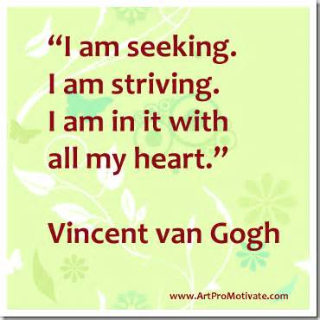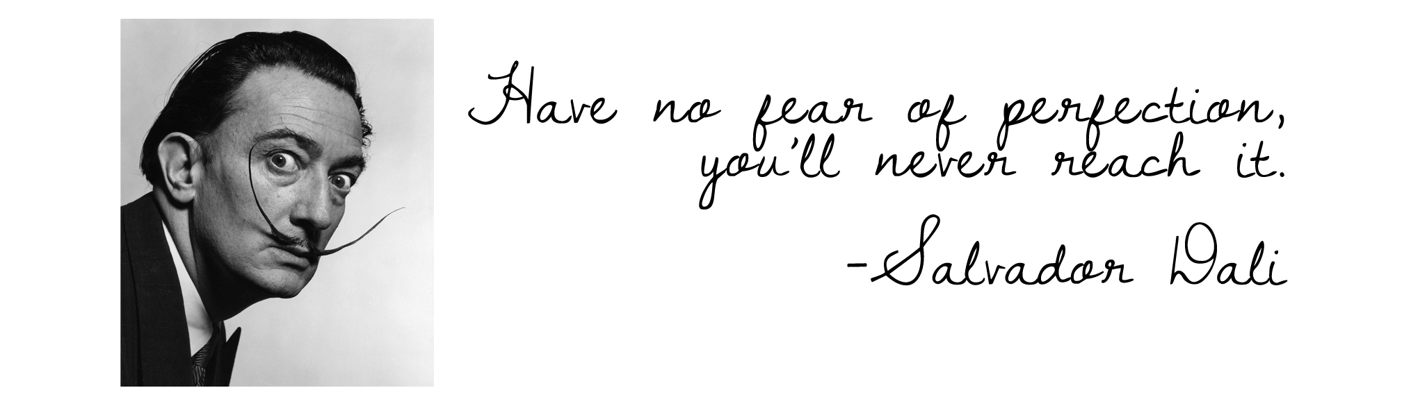

Please complete fully and return this page to Mrs. Sawyer by September 1, 2015. 40 points

East High School – Visual Art Expectations
Drawing and Painting 2

“By signing below, I acknowledge understanding of what will make this a successful experience and I agree to adhere to all expectations of the Drawing and Painting 2 class as well as those imposed by East High School and Denver Public Schools.”

_____I agree to have my artwork considered for display in school displays and local or district exhibitions and online to promote the East art department.

_____I understand that I will be creating a personal website that will focus on my artwork and assignments for this class.

Bonus Points: Describe a goal you have for this course:
________________________________________________________________________________________________________________________________________________________________________________________________________________________________________________________________________________________________________________________________________________________________________

Student Name: ______________________________________________ Period:________
Signature: __________________________________________________ Date: _______________

Parent/Guardian Name: _______________________________________
Signature: __________________________________________________ Date: ______________

Materials Fee for this course is $40.00/year and is due on September 15.
*Students are expected to pay $40.00 for the year for this course. This fee helps provide students with many diverse marking materials needed for success in this course. Please see the treasurer outside the main office to pay your fee. If the fee is a financial hardship, students may apply for financial aid from the East High School Angel Foundation in Room 130. Students must demonstrate the financial burden in order to receive financial assistance. You will receive 40 participation points for taking care of this task by Sept. 15. Bring receipt from the treasurer or signed paperwork from the Angel Foundation to receive credit.

Please contact Mrs. Sawyer at justine_sawyer@dpsk12.org if you have any questions or concerns.

